$Linear Regression Evaluation Methods$

$Our main goal In linear regression is identify the coeff$

$in order to minise the cost function$

$So cost function is One of our Evaluation metric$

$In Regression problem or Forecasting problem$

$We have some metrics will be avilable$

$Metrics will provide the perfomance of the model , that we are calling as$

$Model evaluation$

$MSE or Cost$

$RMSE$

$RSE$

$R-square$

$Adjusted R square$

$AIC:Akaiki Information creteria$

$BIC:Baysian Information Creteria$

$MSE:Mean square error$

$MSE=\frac{1}{n}*SSE$

$MSE=\frac{1}{n}*\sum_{i=1}^{n}{}{\left(y_{a_{i}}-y_{p_{i}}\right)}^{2}$

$ROOT MEAN SQUARE ERRORS \left(RMSE\right)$

$RMSE=\sqrt{MSE}$

$RMSE=\sqrt{\frac{1}{n}*\sum_{i=1}^{n}{}{\left(y_{a_{i}}-y_{p_{i}}\right)}^{2}}$

$RSE:Residual Standard error$

$Statistics part1-Standard deviation$

$How much an observation deviated from population mean$

$Statistics part2-Standard error$

$How much a sample mean deviated from population mean$

$Linear regression:Residual stanadrd error$

$How a sample regression is deviating from population regression line$

$Here also we divided our data into samples$

$each sample we will get one regression line$

$that regression never equal to population regression line$

$it has some deviation , that deviation we can measure interms of RSE$

$In other words RSE will give some error even though when we have a best fit line$

$RSE is irreducible error$

$RSE will calculate after we got best fit line$

$Standard deviation=σ=\sqrt{var}= \sqrt{\frac{1}{n}\sum_{i=1}^{n}{}{\left(x_{i}-\underline{x}\right)}^{2}}$

$Standard Error=\frac{σ}{\sqrt{n}}$

$RSE=\sqrt{\frac{1}{n-p-1}\sum_{i=1}^{n}{}{\left(y_{actual}-y_{predicted}\right)}^{2}}$

$\sum_{i=1}^{n}{}{\left(y_{actual}-y_{predicted}\right)}^{2}= SSE=RSS$

$RSE=\sqrt{\frac{RSS}{n-p-1}}$

$p=predictors=number of input columns$

$n=number of observation$

$RSE=\sqrt{\frac{1}{n-p-1}\sum_{i=1}^{n}{}{\left(y_{actual}-y_{predicted}\right)}^{2}}=\sqrt{\frac{RSS}{n-p-1}}$

$Sales=b_{o}+b_{1}*TV+b_{2}*SM+b_{3}*NP$

$RSE=\sqrt{\frac{RSS}{n-3-1}= }\sqrt{\frac{RSS}{n-4}}$

$R-square$

${\hat{y}}_{i} or y_{p}=model predictions, y_{i}=actual output, {\underline{y}}_{i}=average actual output value$

$SS_{Total}=SS_{Residuals}+SS_{Explained}$

$SS_{Total}=Total Sum of squares$

$SS_{Residuals}=Residual sum of squares$

$SS_{Explained}=Explained sum of squares$

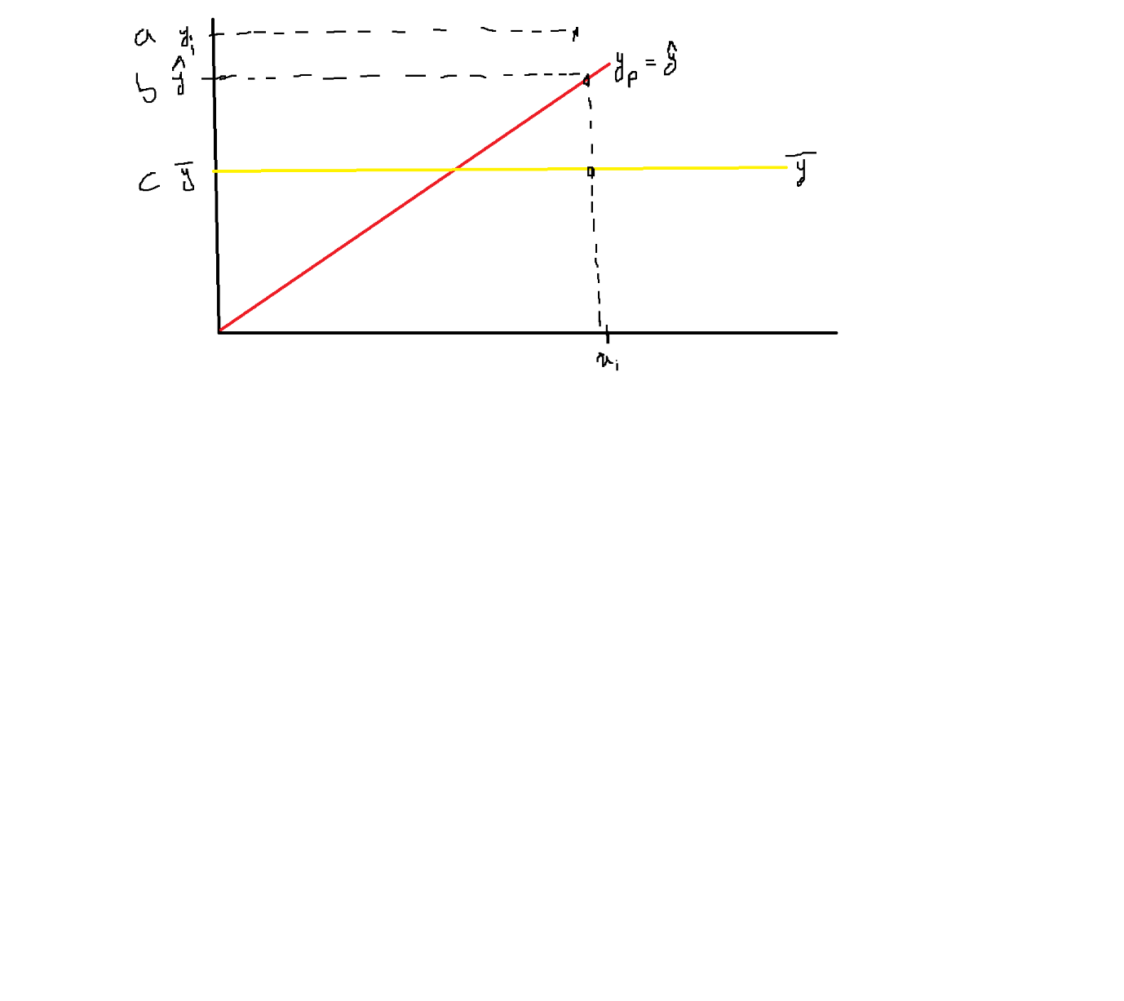

$\sum_{i=1}^{n}{}{\left(y_{ai}-\underline{y}\right)}^{2}=\sum_{i=1}^{n}{}{\left(y_{ai}-{\hat{y}}_{i}\right)}^{2}+\sum_{i=1}^{n}{}{\left({\hat{y}}_{i}-\underline{y}\right)}^{2}$

${\hat{y}}_{i}-\underline{y}=explained error after LR and average value$

$SS_{Total}=SS_{Residuals}+SS_{Explained}$

$SS_{Total}/SS_{Total}=SS_{Residuals}/SS_{Total}+SS_{Explained}/SS_{Total}$

$1=\frac{SS_{Residuals}}{SS_{Total}}+\frac{SS_{Explained}}{SS_{Total}}$

$\frac{SS_{Explained}}{SS_{Total}}=1-\frac{SS_{Residuals}}{SS_{Total}}$

$R-squared=1-\frac{SS_{Residuals}}{SS_{Total}}$

$R-squared=1-\frac{sum of squared residuals \left(SSR\right)}{Total sum of squares\left(SST\right)}$

$R-squared=1-\frac{\sum_{i=1}^{n}{}{\left(y_{i}-{\hat{y}}_{i}\right)}^{2}}{\sum_{i=1}^{n}{}{\left(y_{i}-\underline{y}\right)}^{2}}$

$R-squared=1-\frac{Error due to Regression model}{Error due to Mean model}$

$R-squared Interpretation$

$R-squared is called as Coefficient of Determination$

$R-squared is also called as Good ness of fit$

$R_{sq} exaplained how much variabiality in output column based on input column$

$How much percentage of variance in output column explained by input column$

$R-squared is varies from 0 to 1$

$More R_{Square} value indicates good model$

$R_{Square} gives the idea of explainability of model$

$For example$

$sales=b_{o}+b_{1}*TV$

$assume that by using OLS method we identify the coeff values$

$sales=1000+20*TV ===== > LR model$

$Evaluated the model$

$Model is Giving R_{Square}=0.8$

$80\% of variance in sales is explained by TV$

$son=b_{o}+b_{1}*mama$

$90\% of variance in son is explained by mamma$

$son=b_{o}+b_{1}*mama+b_{2}*papa$

$95\% of variance in son is explained by mamma$

$son=b_{o}+b_{1}*mama+b_{2}*papa+b_{3}*friend$

$100\% of variance in son is explained by mamma$

$Note:$

$R_{Square} value keep on increase when you add the variable$

$R-squared=1-\frac{\sum_{i=1}^{n}{}{\left(y_{i}-{\hat{y}}_{i}\right)}^{2}}{\sum_{i=1}^{n}{}{\left(y_{i}-\underline{y}\right)}^{2}}$

| X | Y ${=y}_{i}$ | Y_p= ${\hat{y}}_{i}=$ 0.143+1.229x | $y_{i}-{\hat{y}}_{i}$ | ${(y}_{i}-{\hat{y}}_{i})^2$ | $y_{i}-\underline{y}$ | ${\left(y_{i}-\underline{y}\right)}^{2}$ |
| --- | --- | --- | --- | --- | --- | --- |
| 2 | 2 |  |  |  |  |  |
| 3 | 4 |  |  |  |  |  |
| 4 | 6 |  |  |  |  |  |
| 6 | 7 |  |  |  |  |  |
|  |  |  |  |  |  |  |

| X | Y ${=y}_{i}$ | Y_p= ${\hat{y}}_{i}=$ 0.143+1.229x | Residual $y_{i}-{\hat{y}}_{i}$ | Square of residual ${(y}_{i}-{\hat{y}}_{i})^2$ | $\underline{y}$ | $y_{i}-\underline{y}$ | ${(y}_{i}-\underline{y})^2$ |
| --- | --- | --- | --- | --- | --- | --- | --- |
| 2 | 2 | 2.601 | 2-2.601=-0.601 | 0.361201 | 4.75 | 2-4.75=-2.75 | 7.5645 |
| 3 | 4 | 3.83 | 4-3.83=0.17 | 0.0289 | 4.75 | 4-4.75=-0.75 | 0.5625 |
| 4 | 6 | 5.059 | 6-5.059=0.941 | 0.885481 | 4.75 | 6-4.75=1.25 | 1.5625 |
| 6 | 7 | 7.517 | 7-7.517=-0.517 | 0.2672 | 4.75 | 7-4.75=2.25 | 5.0625 |
|  |  |  | SSR= | 1.542871 |  |  | 14.75 |

$\sum_{i=1}^{n}{}{\left(y_{i}-{\hat{y}}_{i}\right)}^{2}=1.542871$

$\sum_{i=1}^{n}{}{\left(y_{i}-\underline{y}\right)}^{2}=14.75$

$R-squared=1-\frac{1.542871}{14.75}=0.8954$

number lectures per day affects the number of hours spent at university per day

$no_of_lectures=$ 0.143+1.229*Hours spent

$R_{Squared}=0.8954$

89% of variance in lecture explain by hours

The number of lectures are varying w.r.t hours , is that True ?

Yes

$Problem using R_{Square}$

$we alreday know R_{square} value keep on incresae when we add variable in the model$

$For example a data has 100 columns$

$You used 50 columns :$

$y=b_{o}+b_{1}*x_{1}+b_{2}*x_{2}+….+b_{50}*x_{50}===== > R_{square}=0.8$

$You used 60 columns :$

$y=b_{o}+b_{1}*x_{1}+b_{2}*x_{2}+….+b_{60}*x_{60}===== > R_{square}=0.9$

$You used 100 columns :$

$y=b_{o}+b_{1}*x_{1}+b_{2}*x_{2}+….+b_{100}*x_{100}===== > R_{square}=1$

$whenever we have 100\% accuracy , then the model is called as overfit$